System and Software Architecture Description (SSAD)

Farmworkers Safety App

Team 09

TEAM MEMBER NAME | ROLES
Juan Andrade | Project Manager  Life Cycle Planner  Developer
Theerapat Chawannakul | System Architect  Developer
Fereshteh Khorzani | Independent Verification and Validation  Quality Focal Point
Basir Navab | Life Cycle Planner  Developer
Vahagen Sinanian | Operational Concept Developer  Developer
David Tasky | Independent Verification and Validation  Quality Focal Point

04/19/2017
VERSION HISTORY

Date | Author | Version | Changes Made | Rationale
10/12/2016 | Shobhit Agarwal | 1.0 | Sections 1 and 2 diagrams added | Draft for the FCR ARB Submission
10/16/2016 | Viraj Sahai | 1.1 | Sections 1 and 2 completed | Final copy for FCR ARB Submission
10/17/2016 | Shobhit Agarwal | 1.2 | Adding section 2.2, adding header and footers, and formatting the document | Final copy for FCR ARB submission
11/26/2016 | Viraj Sahai | 2.0 | Added section 3 and 4 | Draft of final copy for DCR TRR ARB
12/02/2016 | Juan Andrade | 2.1 | Completed all sections | Final copy for DCR TRR ARB
12/05/2016 | Viraj Sahai | 2.2 | Finalized the document | Final copy for upload
02/12/2017 | Theerapat Chawannakul | 3.0 | Changed members of the team and updated architecture of system | Final copy for Re-baselined ARB
04/19/2017 | Juan Andrade | 3.1 | Updated Process Realization Diagrams and Added Class Diagram | Updated Copy for As Built Package.

Table of Contents
System and Software Architecture Description (SSAD) i
Table of Contents iii
Table of Tables iv
Table of Figures vi
1. Introduction 1
1.1 Purpose of the SSAD 1
1.2 Status of the SSAD 1
2. System Analysis 2
2.1 System Analysis Overview 2
2.2 System Analysis Rationale 16
3. Technology Dependent System Design 17
3.1 System Overview 17
4. Architectural Style, Patterns and Frameworks 20

Table of Tables
Table 1: Actors Summary Error: Reference source not found
Table 2: Artifacts and Information Summary Error: Reference source not found
Table 3: Process Description-login 8
Table 4: Typical Course of Action-login: successful 8
Table 5: Alternate Course of Action-login: fail 8
Table 6: Process Description-logout Error: Reference source not found
Table 7: Typical Course of Action-logout Error: Reference source not found
Table 8: Alternate Course of Action-logout:fail Error: Reference source not found
Table 9: Process Description-registration Error: Reference source not found
Table 10: Typical Course of Action-registration Error: Reference source not found
Table 11: Alternate Course of Action—registration:fail Error: Reference source not found
Table 12: Process Description-update profile Error: Reference source not found
Table 13: Typical Course of Action-update profile Error: Reference source not found
Table 14: Alternate Course of Action— update profile:fail Error: Reference source not found
Table 15: Process Description-update location Error: Reference source not found
Table 16: Typical Course of Action-update location Error: Reference source not found
Table 17: Alternate Course of Action—update location:fail Error: Reference source not found
Table 18: Process Description-add farms Error: Reference source not found
Table 19: Typical Course of Action-add farms:success Error: Reference source not found
Table 20: Alternate Course of Action-add farms:fail Error: Reference source not found
Table 21: Process Description-delete farms Error: Reference source not found
Table 22: Typical Course of Action-delete farms:success Error: Reference source not found
Table 23: Alternate Course of Action-delete farms:fail Error: Reference source not found
Table 24: Process Description-manage farmworkers Error: Reference source not found
Table 25: Typical Course of Action-manage farmworkers:success Error: Reference source not found
Table 26: Alternate Course of Action-manage farmworkers:fail Error: Reference source not found
Table 27: Process Description-search farmworkers Error: Reference source not found
Table 28: Typical Course of Action-search farmworkers:success Error: Reference source not found
Table 29: Alternate Course of Action-search farmworkers:fail Error: Reference source not found
Table 30: Process Description-manage users Error: Reference source not found
Table 31: Typical Course of Action-manage users:success Error: Reference source not found
Table 32: Alternate Course of Action-manage users:fail Error: Reference source not found
Table 33: Process Description-search users 13
Table 34: Typical Course of Action-search users:success Error: Reference source not found
Table 35: Alternate Course of Action-search users:fail 14
Table 36: Process Description-manage media content 14
Table 37: Typical Course of Action-manage media content:success 14
Table 38: Alternate Course of Action-manage media content:fail 15
Table 39: Process Description-manage quiz 15
Table 40: Typical Course of Action-manage quiz:success 15
Table 41: Alternate Course of Action-manage quiz:fail 16
Table 42: Process Description-notification system 16
Table 43: Typical Course of Action-notification system 17
Table 44: Hardware Component Description 17
Table 45: Software Component Description 18
Table 46: Design Class Description 21
Table 47: Architectural Styles, Patterns and Frameworks 25

Table of Figures

Figure 1: System Context Diagram Error: Reference source not found
Figure 2: Artifacts and Information Diagram Error: Reference source not found
Figure 3: Process Diagram Error: Reference source not found
Figure 4: Hardware Component Design 17
Figure 5: Software Component Design 18
Figure 6: Deployment Diagram 19
Figure 7: System Class Diagram 20
Figure 8, 9, 10,11: Process Realization Diagram 24-26

Introduction

Purpose of the SSAD
The purpose of this SSAD is to document the design of the Farmworker Safety App. The SSAD will be a guiding tool for analysis and detailed description of the system architecture. It would serve as a reference for the future software developer/maintainer to understand and enhance the design in the future.

Status of the SSAD
-Sections 1 and 2 have been completed for Foundations Commitment Package.
-All other sections will be completed at a later date.
-Naming conventions are likely to change in further revisions (refer to section 2.2 System Analysis Rationale for further details).

System Analysis

System Analysis Overview
The main purpose of the Farm Worker App is to provide notifications to farmworkers and farmers about the temperature levels if it exceeds a threshold so that they can take breaks and save themselves from heat related stress. The app will also collect feedback from the farmers regarding their health conditions so that they can be monitored for symptoms of heat related stress. It will also include emergency services like one touch call to CalOsha, 911 and other emergency contacts. It may also provide a platform for contractors and farmers to search for available farmworkers looking for jobs.

System Context

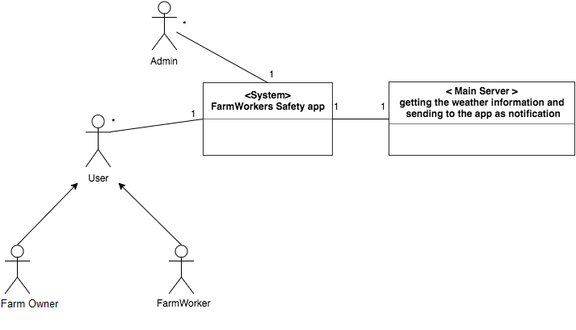

Figure 1: System Context Diagram

Table 1: Actors Summary
Actor | Description | Responsibilities
Admin | Administrators to manage the system and functionalities | Control user access rights; manage data; post content; manage users
User (Farm Owner) | Users that own farm | Manage farmworkers; register new farmworkers to the farm; hire farmworkers
User (Farm Worker) | Users that work on the farms | Submit feedback; take quizzes; update location; get himself educated; take preventive measures

Artifacts & Information
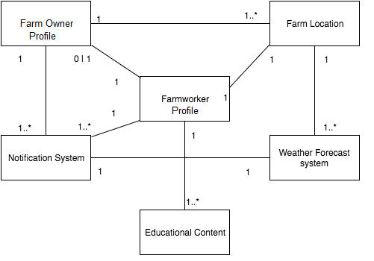
Figure 2: Artifacts and Information Diagram
Table 2: Artifacts and Information Summary
Artifact | Purpose
Farmworker Profile | Contains information regarding the farmworkers
Farmer Profile | Contains information regarding the farmer/contractor
Farm Location | Location of the farm at which the farmworker is working
Notification System | Provides notifications to the farmworkers regarding temperature, quizzes and feedback
Educational Content | Videos and Quizzes to educate the farmworkers regarding heat related stress and prevention practices
Weather Forecast System | Fetches weather information to be able to send notifications to the farmworkers

Behavior

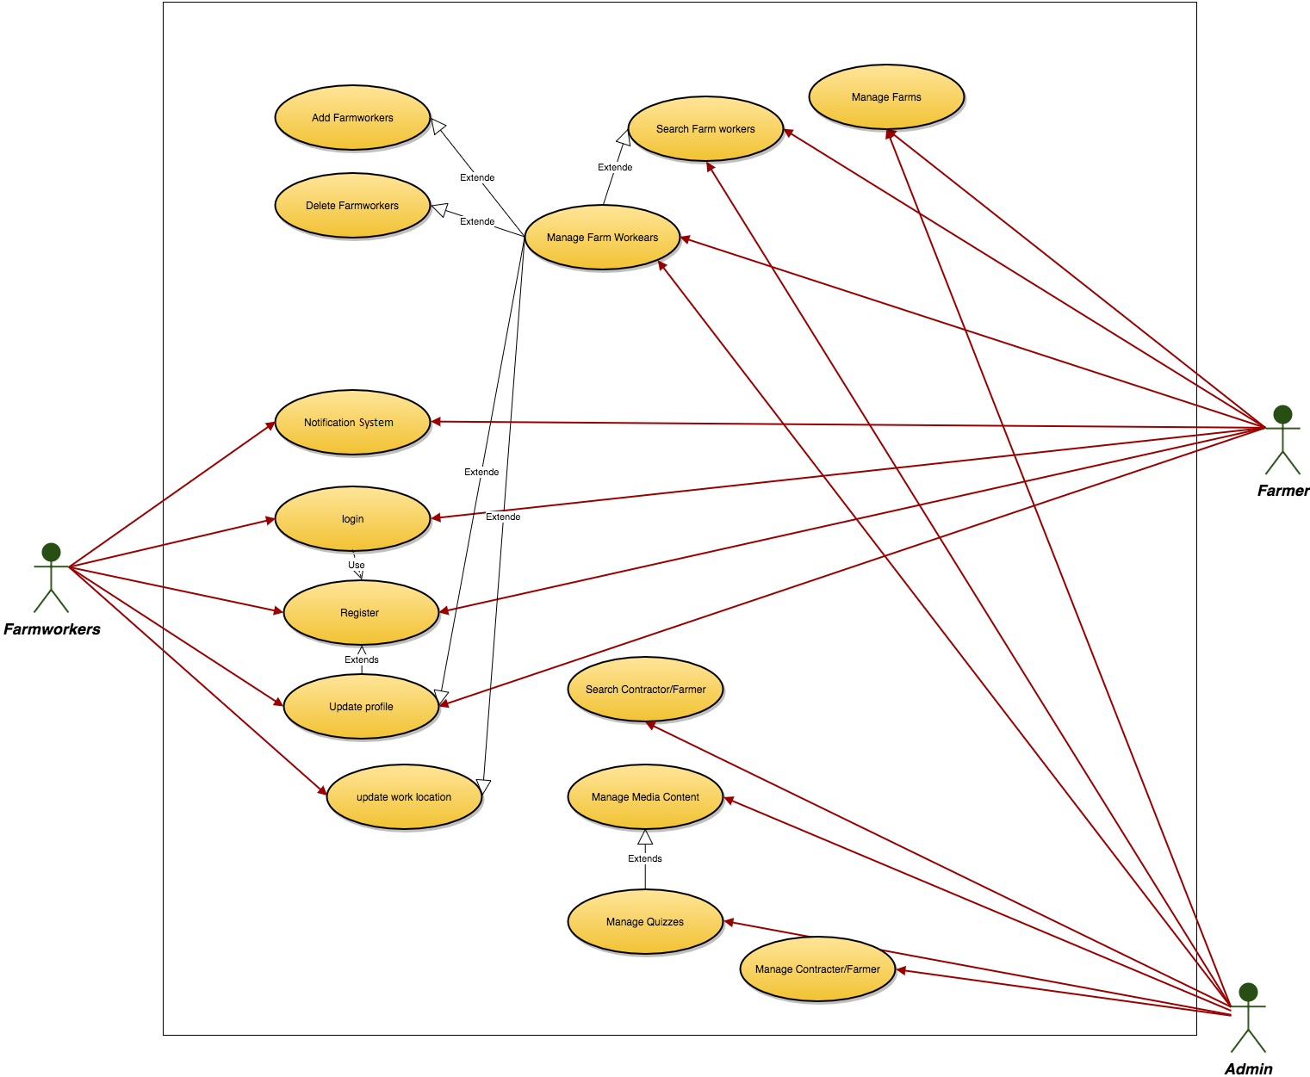
Figure 3: Process Diagram

2.1.3.1 Authentication
2.1.3.1.1 Login

Table 3: Process Description-login
Identifier | login
Purpose | Determine if a person logging in to the system can be authenticated, and, if so, what the person’s privileges are as a user.
Requirements | Authorization and Authentication
Development Risks | None
Pre-conditions | System database is properly initialized.  Login functionality is successfully implemented.
Post-conditions | If user exists in the system the user shall be logged in with appropriate access rights

Table 4: Typical Course of Action-login: successful
Seq# | Actor’s Action | System’s Response
1 | User enter username and password and click enter
2 |  | Check whether username and password is true.
3 |  | Redirect user to user’s main page

Table 5: Alternate Course of Action-login: fail
Seq# | Actor’s Action | System’s Response
1 | User enter username and password and click enter
2 |  | Check whether username and password is true.
3 |  | Return error message like “user name or password incorrect” or “user doesn’t exist”

2.1.3.1.1 Logout

Table 6: Process Description-logout
Identifier | logout
Purpose | Logout the user from the system
Requirements | Authorization and Authentication
Development Risks | None
Pre-conditions | User is a valid system user  User is logged in to the system and the session exists.
Post-conditions | The login session is terminated.

Table 7: Typical Course of Action-logout: successful
Seq# | Actor’s Action | System’s Response
1 | User clicks on the logout button
2 |  | User is logged out of the system and a message is displayed saying “ You have been successfully logged”

Table 8: Alternate Course of Action-logout: fail
Seq# | Actor’s Action | System’s Response
1 | User logs out an expired session
2 |  | Return session expired message and return to log in page

2.1.3.2 Registration
2.1.3.2.1 User Registration

Table 9: Process Description-Registration
Identifier | Registration
Purpose | Register user to the system
Requirements | Internet connection on user end.  Registration webpage.
Development Risks | None
Pre-conditions | User is not an already registered user  User has loaded the registration page
Post-conditions | User is registered to the system
Table 10: Typical Course of Action-Registration: successful
Seq# | Actor’s Action | System’s Response
1 | User fills in the registration form
2 |  | User is registered into the database
3 |  | Redirect user to the main profile page

Table 11: Alternate Course of Action-Registration: fail
Seq# | Actor’s Action | System’s Response
1 | Already a registered user tries re-registering
2 |  | Return a “user already registered” error

2.1.3.3 Profile Management
2.1.3.3.1 Update Profile

Table 12: Process Description-Update Profile
Identifier | Update profile
Purpose | Update personal user profile
Requirements | User should be registered
Development Risks | None
Pre-conditions | User should be logged in
Post-conditions | Profile data is updated in the database

Table 13: Typical Course of Action-Update Profile: successful
Seq# | Actor’s Action | System’s Response
1 | User updates the required field
2 |  | User data is updated in the database and a message is displayed as “Profile Updated”

Table 14: Alternate Course of Action-Update Profile: fail
Seq# | Actor’s Action | System’s Response
1 | User updates unique data like email to one that is already registered
2 |  | Return a “Update failed. Email already registered to another user” error

2.1.3.3.2 Update Location

Table 15: Process Description-Update Location
Identifier | Update work location
Purpose | Update location of user so as to be able to send notifications
Requirements | User should be registered
Development Risks | None
Pre-conditions | User should be logged in
Post-conditions | Location data is updated in the database

Table 16: Typical Course of Action-Update Location: successful
Seq# | Actor’s Action | System’s Response
1 | User updates the location using place name or zip-code
2 |  | Location data is updated in the database and a message is displayed as “Location Updated”

Table 17: Alternate Course of Action-Update Location: fail
Seq# | Actor’s Action | System’s Response
1 | User input invalid place or zip-code
2 |  | Return a “Invalid Location input” error

2.1.3.4 Farm Management
2.1.3.4.1 Manage Farms

Table 18: Process Description-Manage farms
Identifier | Manage Farms
Purpose | Add/Delete Farms; Update Farm attributes like area, facilities etc.; View farm details and list of employed workers
Requirements | User should be registered as a farmer
Development Risks | None
Pre-conditions | User should be logged in  User should be a farmer
Post-conditions | Farm data is updated in the database

Table 19: Typical Course of Action-Manage Farms: successful
Seq# | Actor’s Action | System’s Response
1 | User performs the required changes
2 |  | Farm data is updated in the database and a message is displayed as “Farm data updated”

Table 20: Alternate Course of Action-Manage Farms: fail
Seq# | Actor’s Action | System’s Response
1 | User inputs invalid data like invalid zip-code
2 |  | Return a “Update failed. Invalid zip-code” error

2.1.3.5 Farmworker Management
2.1.3.5.1 Add Farmworker

Table 21: Process Description-Add Farmworker
Identifier | Add farmworkers
Purpose | Add Farmworkers to the Farmer’s farm
Requirements | User should be registered as a farmer
Development Risks | None
Pre-conditions | User should be logged in  User should be a farmer  User should add farmworkers to valid farm
Post-conditions | Farmworker data is updated in the database  Corresponding update also shows in the Farmworkers profile

Table 22: Typical Course of Action-Add Farmworker: successful
Seq# | Actor’s Action | System’s Response
1 | User adds farmworkers
2 |  | Farmworker data is updated in the database and a message is displayed as “Farmworker added”

Table 23: Alternate Course of Action-Add Farmworker: fail
Seq# | Actor’s Action | System’s Response
1 | User adds a farmworker who is not registered to the system
2 |  | Return a “Farmworker not registered” error

2.1.3.5.2 Delete Farmworker

Table 24: Process Description-Delete Farmworker
Identifier | Delete farmworkers
Purpose | Delete Farmworkers from the Farmer’s farm
Requirements | User should be registered as a farmer
Development Risks | None
Pre-conditions | User should be logged in  User should be a farmer  User should delete farmworkers from valid farm
Post-conditions | Farmworker data is updated in the database  Corresponding update also shows in the Farmworkers profile

Table 25: Typical Course of Action-Delete Farmworker: successful
Seq# | Actor’s Action | System’s Response
1 | User deletes farmworkers
2 |  | Farmworker data is updated in the database and a message is displayed as “Farmworker deleted”

Table 26: Alternate Course of Action-Delete Farmworker: fail
Seq# | Actor’s Action | System’s Response
1 | User deleted a farmworker who is not registered to the system
2 |  | Return a “Farmworker not registered” error

2.1.3.5.3 Search Farmworker

Table 27: Process Description-Search Farmworker
Identifier | Search farmworkers
Purpose | Search Farmworkers in the Farmer’s farm to display their info
Requirements | User should be registered as a farmer
Development Risks | None
Pre-conditions | User should be logged in  User should be a farmer
Post-conditions | Farmworker is fetched from the database

Table 28: Typical Course of Action-Search Farmworker: successful
Seq# | Actor’s Action | System’s Response
1 | User searches farmworkers
2 |  | Farmworkers data is fetched from the database and displayed

Table 29: Alternate Course of Action-Search Farmworker: fail
Seq# | Actor’s Action | System’s Response
1 | User searches for farmworker not registered in the system
2 |  | Return a “Farmworker not found” error

2.1.3.6 User Management
2.1.3.6.1 Manage Users

Table 30: Process Description-Manage Users
Identifier | Manage Contractors/Farmworkers
Purpose | Add/Delete users; Update user data
Requirements | User should be registered as an admin
Development Risks | None
Pre-conditions | User should be logged in  User should be an admin
Post-conditions | Farmworker data is updated in the database  Corresponding update also shows in the Farmworkers profile

Table 31: Typical Course of Action-Manage Users: successful
Seq# | Actor’s Action | System’s Response
1 | User updates other users’ data
2 |  | Users’ data is updated in the database and a message is displayed as “User Updated”

Table 32: Alternate Course of Action-Manage Users: fail
Seq# | Actor’s Action | System’s Response
1 | User updates unique data fields leading to table constraints violations
2 |  | Return a “User with same data already present” error

2.1.3.6.2 Search Users

Table 33: Process Description-Search Users
Identifier | Search Contractors/Farmworkers
Purpose | Search users
Requirements | User should be registered as an admin
Development Risks | None
Pre-conditions | User should be logged in  User should be an admin
Post-conditions | Farmworker data is fetched from the database

Table 34: Typical Course of Action-Search Users: successful
Seq# | Actor’s Action | System’s Response
1 | User searches for other users’ data
2 |  | Users’ data is fetched from the database and displayed

Table 35: Alternate Course of Action-Search Users: fail
Seq# | Actor’s Action | System’s Response
1 | User searches for a non-existent user
2 |  | Return a “User not found” error

2.1.3.7 Content Management
2.1.3.7.1 Manage Media Content

Table 36: Process Description-Manage Media Content
Identifier | Manage Media Content
Purpose | Add/Delete media content
Requirements | User should be registered as an admin
Development Risks | None
Pre-conditions | User should be logged in  User should be an admin
Post-conditions | Media content shows as a post to farmworkers  Notifications are sent to farmworkers

Table 37: Typical Course of Action-Manage Media Content: successful
Seq# | Actor’s Action | System’s Response
1 | User adds educational video
2 |  | Video is added and a “Video Added” message is displayed
Table 38: Alternate Course of Action-Manage Media Content: fail
Seq# | Actor’s Action | System’s Response
1 | User adds content in incorrect format
2 |  | Return a “Unsupported file format” error

2.1.3.7.2 Manage Quizzes

Table 39: Process Description-Manage Quizzes
Identifier | Manage Quizzes
Purpose | Add/Delete Quizzes
Requirements | User should be registered as an admin
Development Risks | None
Pre-conditions | User should be logged in  User should be an admin
Post-conditions | Quiz shows as a post to farmworkers  Notifications are sent to farmworkers

Table 40: Typical Course of Action-Manage Quizzes: successful
Seq# | Actor’s Action | System’s Response
1 | User adds quiz with corrected url
2 |  | Quiz is added and a “Quiz Added” message is displayed

Table 41: Alternate Course of Action-Manage Content: fail
Seq# | Actor’s Action | System’s Response
1 | User add quiz with empty url
2 |  | Return a “Quiz link is required” error

2.1.3.8 Notification System
2.1.3.8.1 Notification System

Table 42: Process Description-Notification System
Identifier | Notification System
Purpose | Send notification to the user
Requirements | User should be registered as a user
Development Risks | None
Pre-conditions | User should be logged in
Post-conditions | Notification is sent to the user and displays in status bar

Table 43: Typical Course of Action-Notification System: successful
Seq# | Actor’s Action | System’s Response
1 |  | System sends temperature and other notifications
2 | Users reacts accordingly

Modes of Operation

Farmworker app will operate in only one mode, so nothing further need be said of modes of operation.

System Analysis Rationale
Administrator registration:
Admin registration has not been included explicitly, as this would be created manually for each admin. Number of admins should be limited and should not be shown in the UI. Only existing admins should be able to add new admins.

User type - Farmer and Contractor:
Both these user types have the same functionality and hence are not being shown explicitly. The only difference in terms of the app between these users is that farmers can manage contractors as well, which will not be covered in the near future, and would be handled manually from the backend for the time being.

Admin can send notification:
Admin has the functionality to send manual notification to the users of the app, but this has not been shown in the use case diagram as this would be one of the implicit feature of the admin user.

Technology Dependent System Design

Design Overview

System Structure

Figure 3: Hardware Component Class Diagram
Table 44: Hardware Component Description
Hardware Component | Description
Farmworker’s Computer | User computer with a web browser
Farmworker’s Mobile | User mobile device with text (and/or data) service
Application Server | Server used to host the web application with PHP configuration
Database Server | Server used to host the enormous user, farm and weather data
Network Component | Device through which the user’s device gains internet access. i.e. Wi-Fi Router

Figure 5: Software Component Class Diagram

Table 65: Software Component Description
These components and descriptions are the same as the technology-independent section except that all components in user interface will be developed with HTML and JavaScript using AngularJS framework, and all components in “Farmworker App” API will be developed with ASP.Net

Software Component | Description
Notification system | The system handles app notification of both temperature events and informing about new educational content.
Profile | The system handles adding/editing/showing users’(Farmworkers and Farmers) profile.
Weather Fetch System | The system will fetch all weather and temperature data by making API calls.
Texting System | The system is responsible for two-way text input and text notification actions.
Home page | Home page consists of current temperature information and new educational content.
SMS Interaction System | This system will use text messages to present user with choices and notifications
Profile page | Profile page allows users’ to share their information and show their information to other users.
Edit Profile Page | This will allow users to update their profile data like age, location etc.
Notification icon | Notification icon shows new temperature and educational content notification.
Admin page | The Admin page allows maintainers to manage users, educational contents, and farms.
Educational Content Page | This page will display all the educational content videos and quizzes categorized accordingly.
Farmer/Contractor Page | This page will display details of farmworkers and farms under the farmer/contractor.

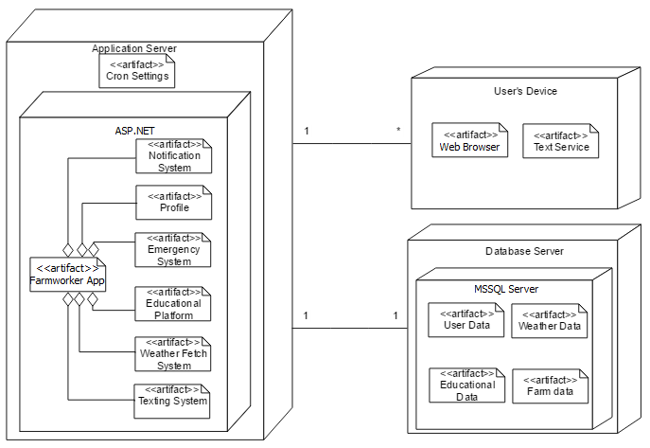
Figure 6: Deployment Diagram

Design Classes

Farmworker Safety System Class Diagram

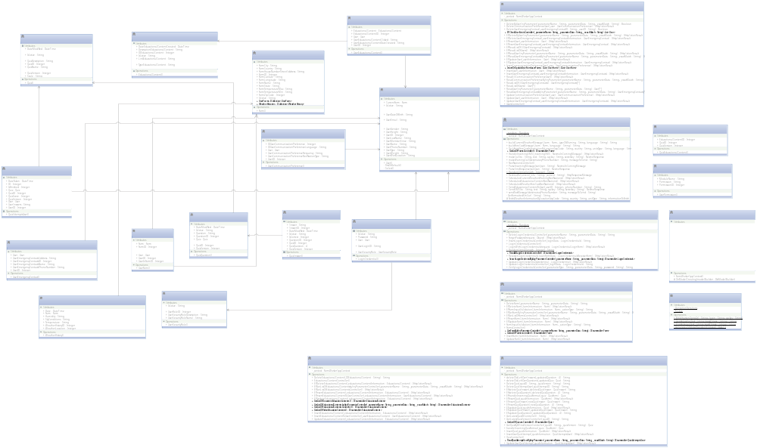

Figure 4: Design Class Diagram

Table 46: Class Dependency Diagram Description
Class | Type | Description
User | Model | This model extends the Model class from the ASP.NET framework consists on User’s data access. (Will be removed in future releases and be replace by its Entity Equivalent)
User | Entity | This class extends the Entity Framework from the ASP.NET Framework, consists on User’s data access. Facilitates database operations.
Farm | Model | This model extends the Model class from the ASP.NET framework consists on Farm’s data access. (Will be removed in future releases and be replace by its Entity Equivalent)
Farm | Entity | This class extends the Entity Framework from the ASP.NET Framework, consists on Farm’s data access. Facilitates database operations.
EducationalContent | Model | This model extends the Model class from the ASP.NET framework consists on Educational Content’s data access. (Will be removed in future releases and be replace by its Entity Equivalent)
EducationalContent | Entity | This class extends the Entity Framework from the ASP.NET Framework, consists on Educational Content’s data access. Facilitates database operations.
Quiz | Model | This model extends the Model class from the ASP.NET framework consists on Quiz’s data access. (Will be removed in future releases and be replace by its Entity Equivalent)
Quiz | Entity | This class extends the Entity Framework from the ASP.NET Framework, consists on the Quiz’s main information data access. Facilitates database operations.
QuizAnswer | Entity | This class extends the Entity Framework from the ASP.NET Framework, consists on the Quizzes Answers Section data access. Facilitates database operations.
QuizQuestion | Entity | This class extends the Entity Framework from the ASP.NET Framework, consists on the Quizzes Questions Section data access. Facilitates database operations.
QuizAttemptsUser | Entity | This class extends the Entity Framework from the ASP.NET Framework, consists on the Quizzes User Responses Section data access. Facilitates database operations.
QuizEducationalContent | Entity | This class extends the Entity Framework from the ASP.NET Framework, consists on the data access of the Educational Content attached to the Quizzes. Facilitates database operations.
Notifications | Model | This model extends the Model class from the ASP.NET framework consists on Notification’s necessary data access. (Will be removed in future releases and be replace by its Entity Equivalent)
FarmWorkersAppContext | Entity | This class extends the Entity Framework from the ASP.NET Framework. It is used to create a database context to work with it throughout the application.
LoginCredentials | Entity | This class extends the Entity Framework from the ASP.NET Framework, consists on the Login Credential’s data access. Facilitates database operations.
UserCommunicationPreference | Entity | This class extends the Entity Framework from the ASP.NET Framework, consists on the User Communication Preferences’ data access. Facilitates database operations.
UserEducationalContent | Entity | This class extends the Entity Framework from the ASP.NET Framework, consists on the User Viewed Educational Contents’ data access. Facilitates database operations.
UserEmergencyContacts | Entity | This class extends the Entity Framework from the ASP.NET Framework, consists on the User Emergency Contact data access. Facilitates database operations.
UserPermission | Entity | This class extends the Entity Framework from the ASP.NET Framework, consists on the User Security Permissions’ data access. Facilitates database operations.
UserSecurityRole | Entity | This class extends the Entity Framework from the ASP.NET Framework, consists on the User Security Role data access. Facilitates database operations.
UserFarm | Entity | This class extends the Entity Framework from the ASP.NET Framework, consists on the data access of the User relationships with farms. Facilitates database operations.
UserController | Controller | This controller extends the Controller class from the ASP.NET framework handles all requests regarding User’s features and functionalities. And prepares the data in a JSON format to be rendered in the front end.
EducationalContentController | Controller | This controller extends the Controller class from the ASP.NET framework handles all requests regarding Educational Content’s features and functionalities. And prepares the data in a JSON format to be rendered in the front end.
QuizController | Controller | This controller extends the Controller class from the ASP.NET framework handles all requests regarding Quiz’s features and functionalities. And prepares the data in a JSON format to be rendered in the front end.
FarmController | Controller | This controller extends the Controller class from the ASP.NET framework handles all requests regarding Farm’s features and functionalities. And prepares the data in a JSON format to be rendered in the front end.
EducationalContentController | Controller | This controller extends the Controller class from the ASP.NET framework handles all requests regarding Educational Content Controller’s features and functionalities. And prepares the data in a JSON format to be rendered in the front end.
NotificationsController | Controller | This controller extends the Controller class from the ASP.NET framework handles all requests regarding Notifications’ features and functionalities. And prepares the data in a JSON format to be rendered in the front end.
Login Credentials Controller | Controller | This controller is included to manage the user’s session activities. Such as Login, Logout, Session Persistent Data, etc. And prepares the data in a JSON format to be rendered in the front end.

Process Realization
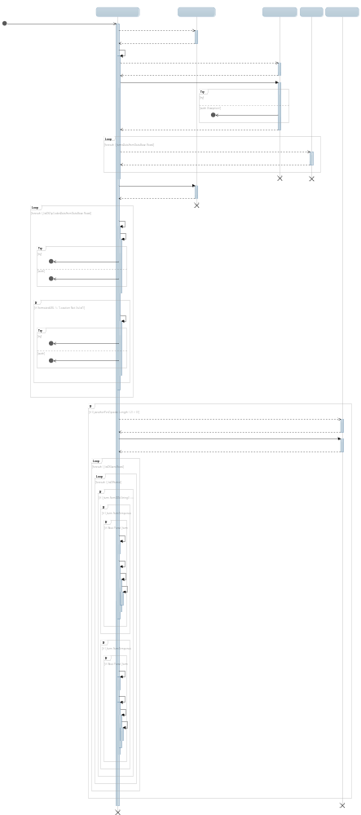

Figure 5: Weather Notification Process Realization Diagram

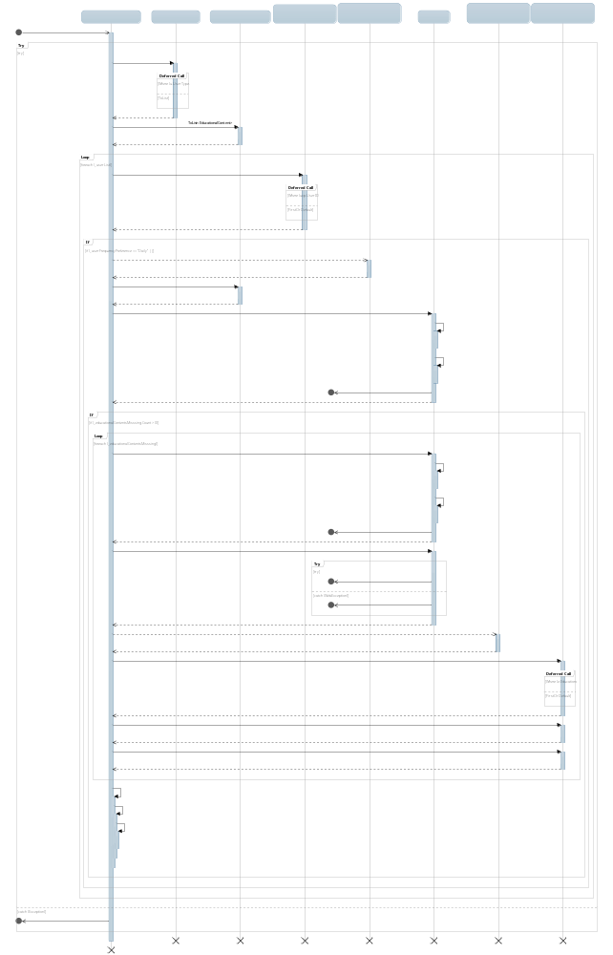

Figure 10: Schedule Educational Content Process Realization Diagram

Click Here to See Full Size Diagram

Figure 10: On-Demand SMS Farm Registration & Educational Content Request
Process Realization Diagram

Design Rationale
As it can be observed on Figure 14, on the design class diagram, we decided to the implement Model-View-Controller architecture, and APS.NET was selected as our framework to reach this goal. In order to successfully implement MVC to that, in the technology dependent design class diagram, all the controllers must extend ASP.NET’s Controller Class, which is provided by the framework, and all the models must extend ASP.NET’S Model Class, which is also provided by the framework of choice. We also decided to use AngularJS as a frontend framework because it is one of most popular framework for web application. Moreover, the framework provides a lot of support for user interface rendering and testing.

Architectural Styles, Patterns, and Frameworks
Table 47: Architectural Styles, Patterns, and Frameworks
Name | Description | Benefits, Costs, and Limitations
3-tier architecture | Separate the application into 3 tiers: a presentation tier using with a web browser/text messages, a logic tier with a ASP.Net server, and a data tier with MSSQL. | - Using web browser allows the user to use any devices that they want, resulting in no need to maintain users’ devices.  - Update through text messages makes the system more robust and platform independent.  - Any change made in the application in the server will be automatically presented to the users.  - There is no cost for adopting the architecture.  - Need to acquire servers for application and database.
MVC | Models, Views, and Controller pattern | - MVC has separate layers for each specific responsibility, resulting in great structures and ease of modifying.  - There are no costs for the pattern.  - If the application is complex, the model layer will be very complicated. So main idea is to keep the system as modular and as simple as possible.
ASP.NET | ASP.NET is a web application framework based on C# | - ASP.NET has very good knowledge documents, tutorials, and community.  - ASP.NET is free for using.  - The team needs to study the framework and good practice before developing the application.
AngularJS | AngularJS is a web application framework based on Javascript | - AngularJS provides an easy way to render user interface.  - Writing unit tests in AngularJS is easy  - It makes the code organized. Thus, maintainers can maintain the system in the future.

